Sponsors

[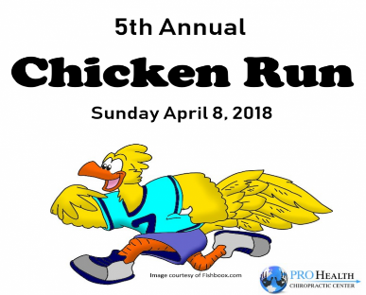](http://www.strongfamilyfarm.org/wp-content/uploads/2018/01/Chicken-Run-Pic-with-Attrition-and-ProHealth-Logo.png)

**Click the sponsor's logo to be taken to their website.**

[](http://www.strongfamilyfarm.org/wp-content/uploads/2018/01/Sponsorship-Gold-blue-background-cropped.png)

[](http://prohealthchiropracticcenter.com/)

[](http://www.strongfamilyfarm.org/wp-content/uploads/2018/01/Sponsorship-Silver-blue-background-cropped.png)

[](http://ctinjurylawyers.com/leighton-katz-drapeau)

[http://www.strongfamilyfarm.org/wp-content/uploads/2018/01/Olenders.png](http://olenders.com/)

[http://www.strongfamilyfarm.org/wp-content/uploads/2018/01/Clay-Furniture-Silver-Sponsor.jpg](http://ctinjurylawyers.com/leighton-katz-drapeau)

[](http://www.strongfamilyfarm.org/wp-content/uploads/2018/01/Sponsorship-Comm-blue-background-cropped.png)

[](http://www.gardenbarn.com/)

[](http://www.advanced-kitchens.com/)

[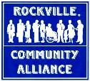](http://www.strongfamilyfarm.org/wp-content/uploads/2018/01/Rockville-Community-Alliance.jpg)

[](https://www.ctvalleyortho.com/)

[](http://www.pricechopper.com/)

[](http://www.dv-photography.com/)

[http://www.strongfamilyfarm.org/wp-content/uploads/2018/01/FISH-Books-Pencil-300x45.jpg](http://fishboox.com/)

[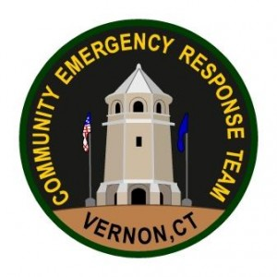](https://www.facebook.com/Vernon-CERT-263635160369743/?hc_ref=SEARCH)

[](http://www.thegrandlofts.com/)

[](http://www.strongfamilyfarm.org/wp-content/uploads/2018/01/santini_villa_apartments_03.png)

[](http://www.tlmracing.com/)

[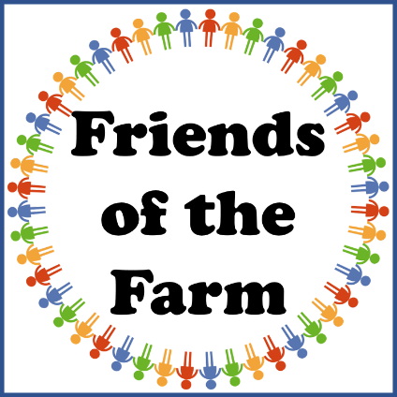](http://www.strongfamilyfarm.org/wp-content/uploads/2018/01/Friends-of-the-Farm.png)

[http://www.strongfamilyfarm.org/wp-content/uploads/2018/01/RONAROLLROLLINGLOGO.png](http://www.strongfamilyfarm.org/wp-content/uploads/2018/01/RONAROLLROLLINGLOGO.png)

[http://www.strongfamilyfarm.org/wp-content/uploads/2018/01/Mark_D_Alliod-with-border1.png](http://www.strongfamilyfarm.org/wp-content/uploads/2018/01/Mark_D_Alliod-with-border1.png)