OUR MISSION:

The preservation of the Strong family’s farm in order to provide a historic agricultural education center where children, individuals, families and community groups can experience an authentic farm environment.

SUPPORT YOUR
COMMUNITY FARM!
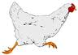

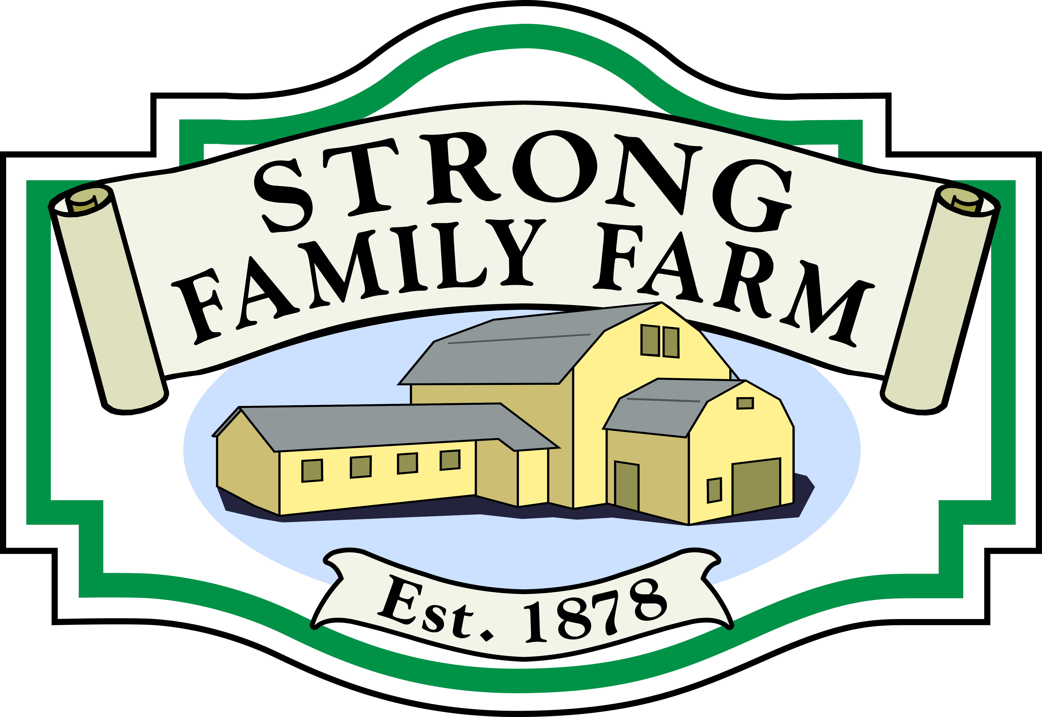
AND
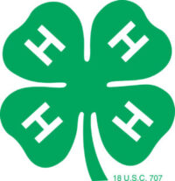
HOP-A-LONG 4-H CLUB

Strong Family Farm
274 West Street
Vernon, CT 06066

Address Correction Required

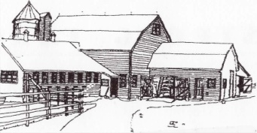

CHICKEN
PROGRAM
2026 application
OR
sign up online!

274 West Street
Vernon, CT 06066
860-874-9020
info@strongfamilyfarm.org
www.strongfamilyfarm.org/
backyard-chicken-program

Strong Family Farm Barn

Children from ages 6 to 96 learn about the life of the chicken and chart its progress.

NEW THIS YEAR
For former Backyard Chicken attendees and older children with familiarity with chickens – our 4-H Club has a chicken program this year. For more information contact us at info@strongfamilyfarm.org.

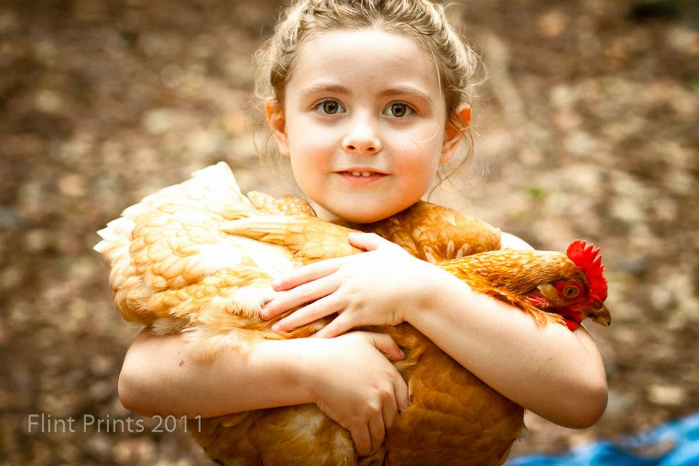

EXTRA FUN
Guess the date of the first egg!

1 guess per supporter
1 guess per date
See calendar located at farm for details.

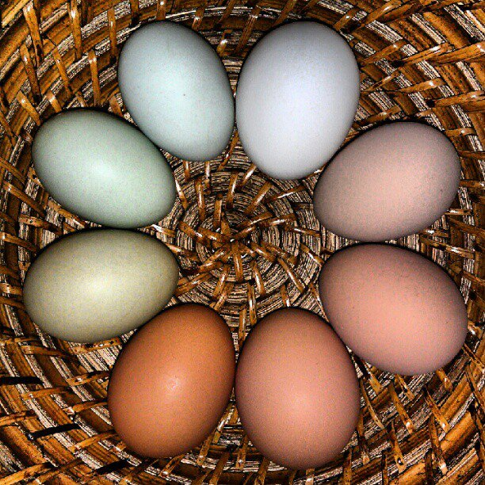

Winner receives a special Strong Family Farm T-shirt!

APPLICATION
Sign up for: |  |  | Price
Backyard Chicken program  8 Tuesdays programs*  5-6 p.m. on 6/30, 7/14, 7/28, 8/11, 8/25, 9/8, 9/22, 10/6  (Harvest Festival 10/18)  STRONG FAMILY FARM “FAMILY MEMBER” DISCOUNT  Interested in helping support a chicken, but not participating in program activities (tax deductible)  *All children must be accompanied and supervised by an adult. Fun for all! |  |  | $60 per  FAMILY  -$30  $_____

Name of Parent/Adult contact
Address
Town State Zip code
Phone Do You Text?
E-mail
Name(s) of Children and ages:

Make check payable to:
“Strong Family Farm, Inc.”

What is the chicken program?

For a small fee of $60, you could play an integral part of a chicken’s life at the farm for the summer and fall. This money will pay for the chicken, feed AND 8 visitations with chicken lessons and activities.
Half price for members & 4-Hers

LEARN:
Over the course of the summer and fall you will learn everything about chickens from the different breeds available to daily care to how they lay their eggs. You will get to spend quality time with the chickens while feeding them, petting them and, in the fall, checking for eggs!

VISITATIONS/PROGRAMS:
At specified dates and times, visitations and activities will be available at the farm at designated dates and times. (See application for details)

Great fun for all –

young and old!

PLEASE NOTE: After the Harvest Festival “Chicken Parade” on Oct 18th, all chickens go to a local farmer to live with other chickens in a nice chicken coop to produce eggs.

Strong Family Farm
274 West Street
Vernon, CT 06066

Phone: 860-874-9020

E-mail: info@strongfarm.org
http://www.strongfamilyfarm.org

