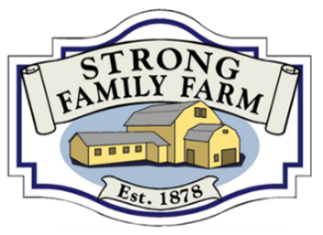
274 West Street, Vernon - “Just Look for the Big Yellow Barn” - www.StrongFamilyFarm.org

Civil War Day Camp

The Civil War Day Camp is a wonderful one-day opportunity for children from ages 8 to 13 to be transported to the early 1860’s and “learn some really cool stuff about life, and how to survive during the Civil war.”

Participants will experience the living conditions of the time, how the armies communicated, how they marched in formation, what they cooked, and much more! Each boy and girl will be given the name of a soldier who actually fought in the civil war and adopt his or her persona for the day.

- Date: Saturday, May 30, 2026  - Time: 9:30 am (roll-call and selection of activities) to 2:00 pm.  - Cost: $30 for the public/$15 members of Strong Family Farm | - Pre-Registration is required.  - No registrations will be done on the day.  - Maximum number of participants: 30  - Note: parents are welcome to stay and enjoy the day!
Visit http://www.strongfamilyfarm.org/civil-war-day-camp/ for more information including how to register

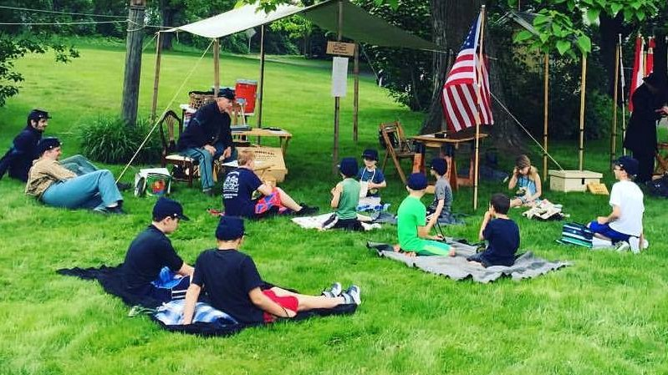

REGISTRATION FOR CIVIL WAR DAY CAMP

To register by mail: Make checks for $30 ($15 dollars if a member of the farm) payable to: Strong Family Farm.

Mail check and completed form to: Strong Family Farm, 274 West Street, Vernon, CT 06066

On the day of the event:
• Bring: 1 blanket suitable for being used as a bed roll, and a bag lunch
• Wear: long pants and suitable footwear for marching is required. No sandals of any kind.
• Water provided

ADULT NAME: _____________________________________________ Cell # _______________________________

Email:_________________________ Address: _________________________________________________________

In Case of Emergency Call:________________________________________ Cell # ______________________
(other than spouse/parent/guardian; i.e. friend, neighbor, grandparent)

PARTICIPANT NAME:_____________________________________________________________________________

DOB and AGE __________________________ M/F

* Allergies/Medication/Other Information (Please specify)
______________________________________________________________________________________________________
______________________________________________________________________________________________________

RELEASE OF LIABILITY: I hereby give my permission for the aforementioned child to participate in the program known as Civil War Day Camp at Strong Family Farm. I do hereby release and discharge the Strong Family Farm, Nancy Strong and Alden Skinner Camp of the Grand Army of the Republic and 14th CT Volunteer Infantry Co. G, it’s agents, servants and volunteers from any liability whatsoever that may result in injury or bodily harm, including death, or property damage that said child might sustain while participating in the aforementioned program(s). I also give permission for the use of photographs taken that day of participant.

Signature of Parent or Guardian________________________________________________

Date:________________

